Tim Berners Lee

CS3012 SOFTWARE ENGINEERING

nuala ní Dhomhnaill

16321005

Early Life

Tim Berners-Less was born in London in 1955 to Mary Lee Woods and Conor Berners-Lee. His parents. He studied in The Queens College in Oxford and graduated with a first-class Bachelor of Arts degree in physics in 1976.

ENQUIRE

Beginning in 1980, Berners-Lee worked as an independent contractor at CERN in Switzerland. Sharing information with researchers in different locations globally via email was an important part of his job. The problem with this is that many people with whom he was working with had both different hardware and software requirements. To make the task of sharing easier he worked on a project which was founded on hypertext. The first prototype was a system known as ENQUIRE. This system was very similar to Apple’s system HyperCard which was only useful for Apple machines. The advantage that ENQUIRE had over Hypertext was that it was able to run on different systems. ENQUIRE is seen as the World Wide Web’s predecessor.

After integrating ENQUIRE with his work at CERN, Berners-Lee quickly realised that most of his time was spent on keeping the data and information shared in the system up to date. One major problem of the system which contributed to this was that Berners-Lee didn’t enable others to use the system effectively. Though ENQUIRE was considered as a failure it prompted Berners-Lee to continue his work and to eventually create the World Wide Web.

The World Wide Web

The Internet had been in use since 1960 and began expanding rapidly in Europe by the mid-1980. However, Berners-Lee wanted to make use of internet nodes and blend it with hypertext and the Domain Name System.

Berners- Lee first began talking about a web-based system while at CERN. With the help of Robert Cailliau, Berners-Lee created the first version of the World Wide Web, the first web browser and the first web server in 1990. However, it was not put online until the following year.

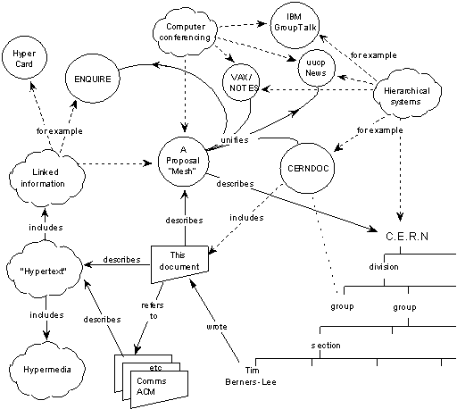

The creation of the World Wide Web has drastically decreases the difficulty of viewing and sharing of information using hypertext web pages. The necessary components of Berners-Lee’s creation are:

* Uniform Resource Locater: locates the address of a web page
* HTML: the standard mark-up language for creating web pages
* HTTP: defines how messages are formatted and transmitted

The Effect of the World Wide Web

The creation of World Wide Web is unarguably the biggest achievement of Tim Berners-Lee and it has had a huge impact on society. Its creation meant that anyone that has access to the internet can browse the web without any cost. It facilitated the development of social media forums, E-Business, blogging and more. Some might consider that the enabling of instant communication is the finest advantage of the World Wide Web as so many people from across the world emigrate away from their friends and families.

Later Achievements

In 2004 Berners-Lee was knighted by Queen Elizabeth II for his incredible work in science and technology. He is the director of the W3C, which overlooks the continued development of the Web. He is also the founder of the World Wide Web Foundation and is a director of the Web Science Research Initiative of the MIT Centre for Collective Intelligence

Very Recently Berners-Lee launched an application called Inrupt, made by the start-up Solid. This app aims to give users control over their data, by controlling which application can use it.

References

Pew Research Center: Internet, Science & Tech. (2018). *Web History Timeline*. [online] Available at: http://www.pewinternet.org/2014/03/11/world-wide-web-timeline/ [Accessed 1 Nov. 2018].

UKEssays. (2018). *Impacts Of The World Wide Web Media Essay*. [online] Available at: https://www.ukessays.com/essays/media/impacts-of-the-world-wide-web-media-essay.php [Accessed 1 Nov. 2018].

W3.org. (2018). *The original proposal of the WWW, HTMLized*. [online] Available at: https://www.w3.org/History/1989/proposal.html [Accessed 1 Nov. 2018].

WhatIs.com. (2018). *What is World Wide Web (WWW)? - Definition from WhatIs.com*. [online] Available at: https://whatis.techtarget.com/definition/World-Wide-Web [Accessed 1 Nov. 2018].

Www-bcf.usc.edu. (2018). *World Wide Web*. [online] Available at: http://www-bcf.usc.edu/~wdutton/comm533/WWW-WANG.htm [Accessed 1 Nov. 2018].